Student Digital Portfolio
Task 2 – Module 2 | CSE0001 Digital Literacy
VIT Bhopal University | Integrated M.Tech in AI | 2025–29
Name | Atharv Singh
Registration No. | 25MIM10198
Branch | Integrated M.Tech in Artificial Intelligence (AI)
Year | First Year (2025–2029)
Course Code | CSE0001 – Digital Literacy
University | VIT Bhopal University
GitHub Username | ATHARVSINGHCHAUHAN
LinkedIn | linkedin.com/in/atharv-chauhan-01574737b
Kaggle | kaggle.com/atharvsingh
Date | 27 March 2026

Introduction

A professional digital presence is essential for every student — especially in a field like Artificial Intelligence where employers actively look for candidates online. As part of Task 2 of the CSE0001 Digital Literacy course, I set up my foundational student digital portfolio across three key platforms: GitHub, LinkedIn, and Kaggle.

As a student of Integrated M.Tech in AI at VIT Bhopal University, these platforms are particularly relevant to my career path. GitHub for code and AI projects, LinkedIn for professional networking and internship opportunities in the AI/ML industry, and Kaggle for hands-on data science and machine learning practice.

Platform 1 – GitHub

GitHub | github.com/ATHARVSINGHCHAUHAN

What is GitHub?
GitHub is the world's leading platform for hosting and sharing code. It uses Git for version control, allowing developers to track changes, collaborate on projects, and maintain a complete history of their work. For AI/ML students, GitHub is where you showcase your machine learning models, data science notebooks, and research projects.

What I Set Up
- Created GitHub account: ATHARVSINGHCHAUHAN
- Created the Digital-literacy-project repository (Public) for CSE0001
- Repository includes README.md, project report, and all task folders
- Made 5 commits in March 2026 — contribution graph is active
- Profile is public and discoverable by employers and professors

Screenshot – GitHub Profile
Figure 1: GitHub Profile – ATHARVSINGHCHAUHAN (March 2026)
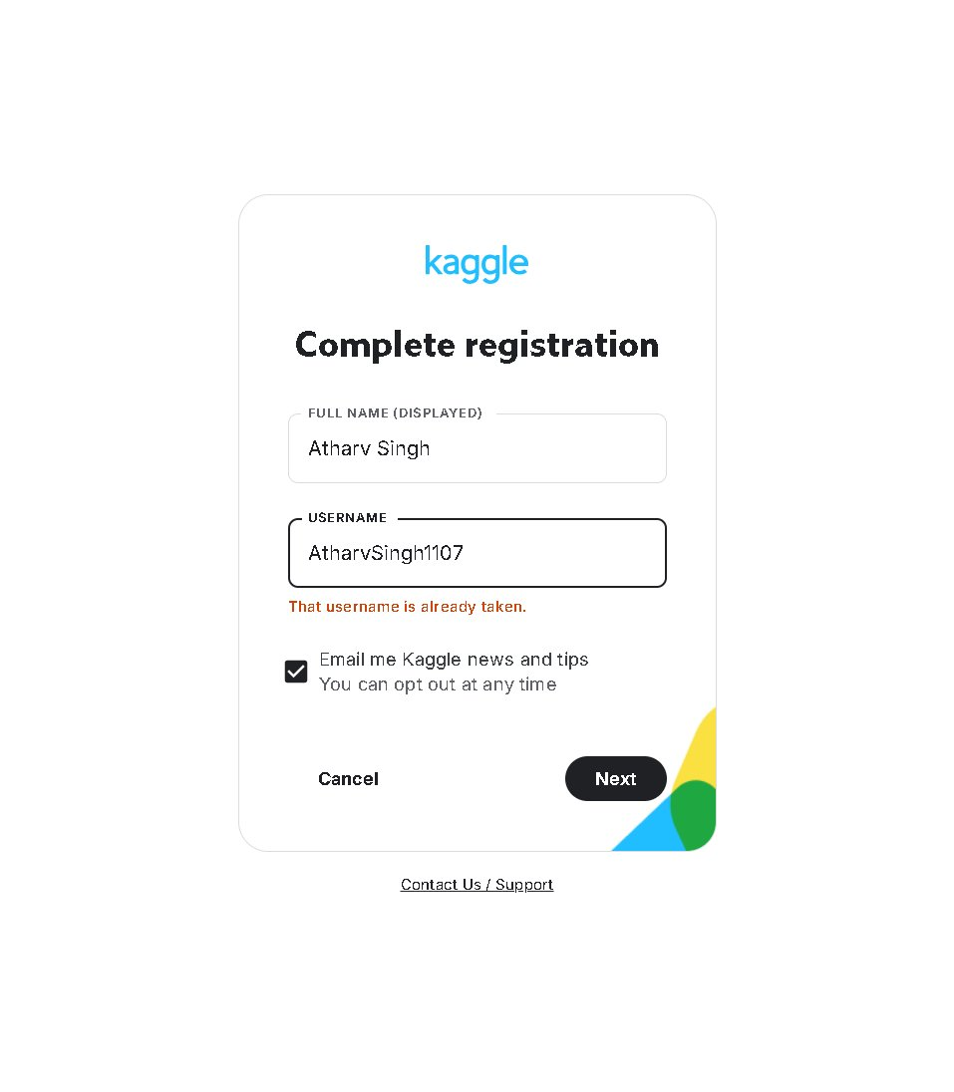

How I Plan to Use GitHub
- Upload AI/ML projects, Jupyter notebooks, and model code
- Showcase assignments, lab work, and semester projects
- Collaborate with classmates using branches and pull requests
- Build a public portfolio that recruiters can review during placements
- Contribute to open source AI projects by third year

Platform 2 – LinkedIn

LinkedIn | linkedin.com/in/atharv-chauhan-01574737b

What is LinkedIn?
LinkedIn is the world's largest professional networking platform with over 900 million users globally. For AI/ML students, LinkedIn is critical for connecting with researchers, data scientists, and technology companies. Recruiters actively search LinkedIn to find candidates — making a strong profile essential from Day 1 of college.

What I Set Up
- Name: Atharv Chauhan
- Headline: VIT Bhopal | AI/ML
- Branch: Integrated M.Tech in Artificial Intelligence
- Institution: Vellore Institute of Technology (VIT Bhopal)
- Location: Bhopal, Madhya Pradesh, India
- Currently 15 connections — growing network
- Profile URL: linkedin.com/in/atharv-chauhan-01574737b

Screenshot – LinkedIn Profile
Figure 2: LinkedIn Profile – Atharv Chauhan, VIT Bhopal | AI/ML
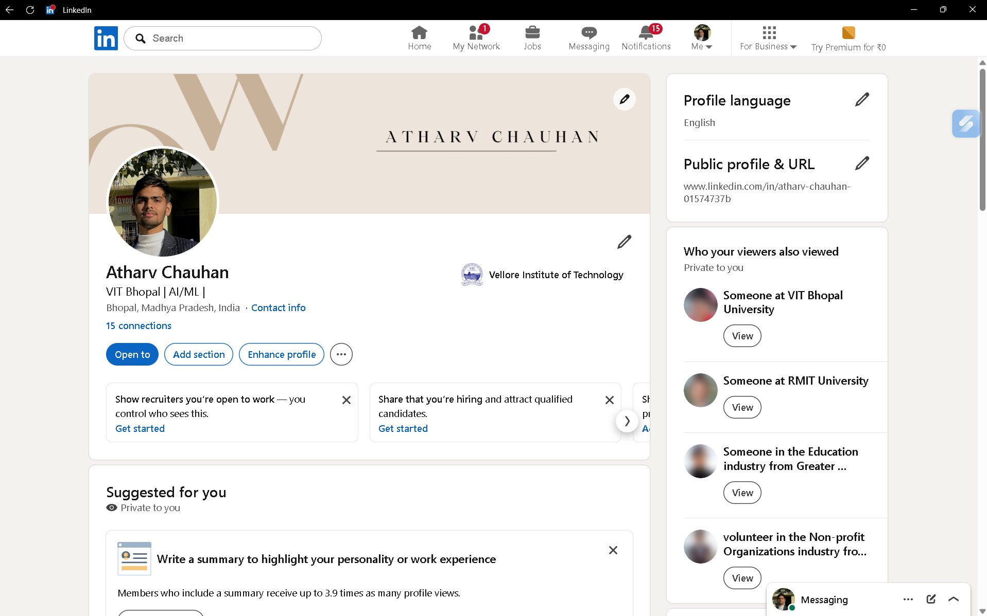

How I Plan to Use LinkedIn
- Connect with AI/ML professionals, researchers, and VIT alumni
- Apply for summer internships at AI and technology companies
- Follow top AI companies: Google DeepMind, OpenAI, Microsoft AI
- Share certifications, project completions, and achievements
- Build a network of 500+ professional connections by final year

Platform 3 – Kaggle

Kaggle | kaggle.com/atharvsingh

What is Kaggle?
Kaggle is the world's largest data science and machine learning community, owned by Google. It provides free datasets, Jupyter notebook environments, ML competitions, and beginner-to-advanced courses. For Integrated M.Tech AI students, Kaggle is the most direct way to build real machine learning skills and a competitive portfolio beyond classroom theory.

What I Set Up
- Full Name: Atharv Singh
- Username: AtharvSingh1107 (registration completed)
- Profile is active — 1-day login streak on first day
- Tier progression: Working toward Contributor tier
- Access to Datasets, Notebooks, Competitions, Courses, and Discussions

Screenshot – Kaggle Dashboard
Figure 3: Kaggle Dashboard – Welcome, Atharv Singh!
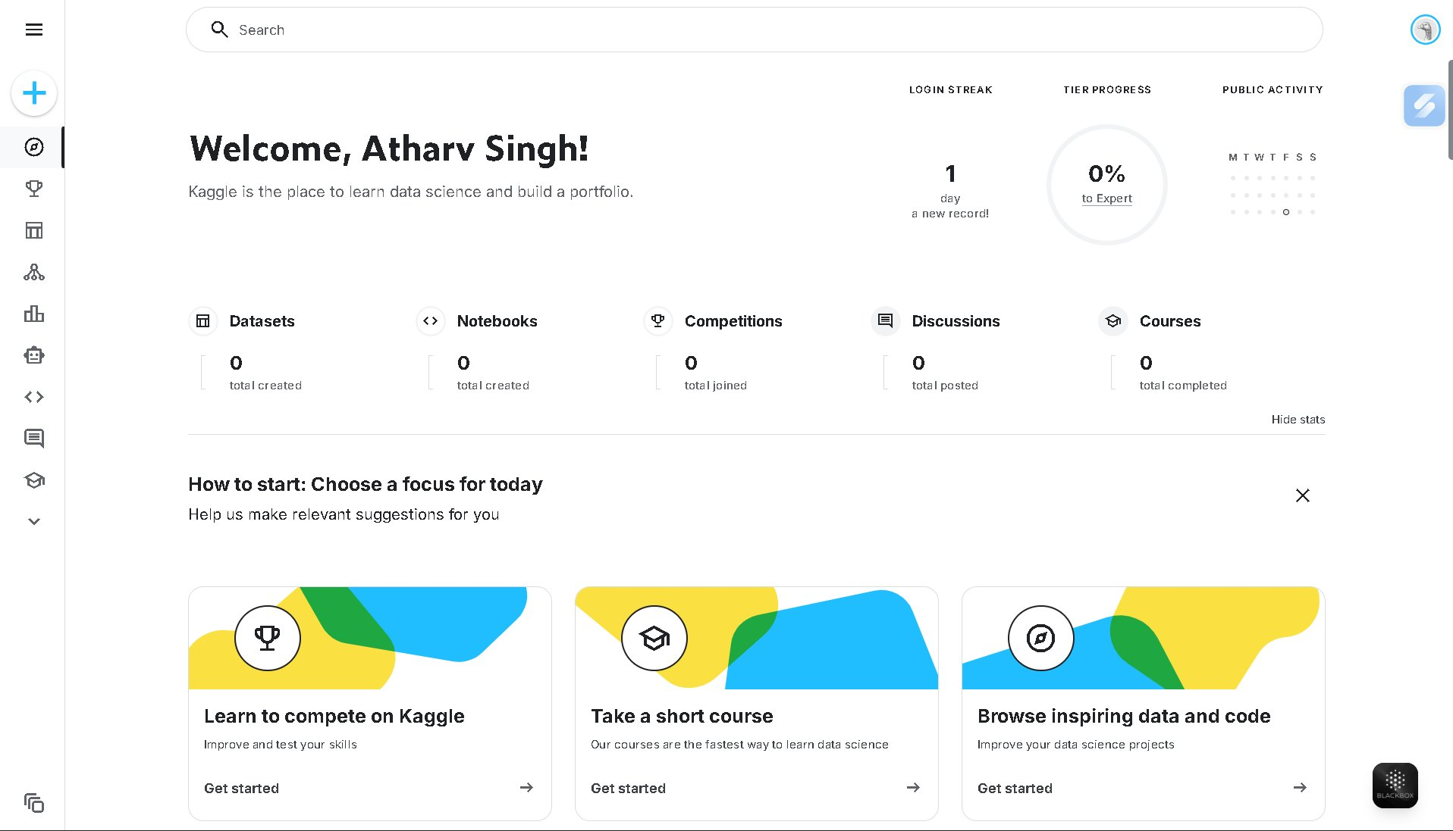

Screenshot – Kaggle Registration
Figure 4: Kaggle Registration – Atharv Singh account setup
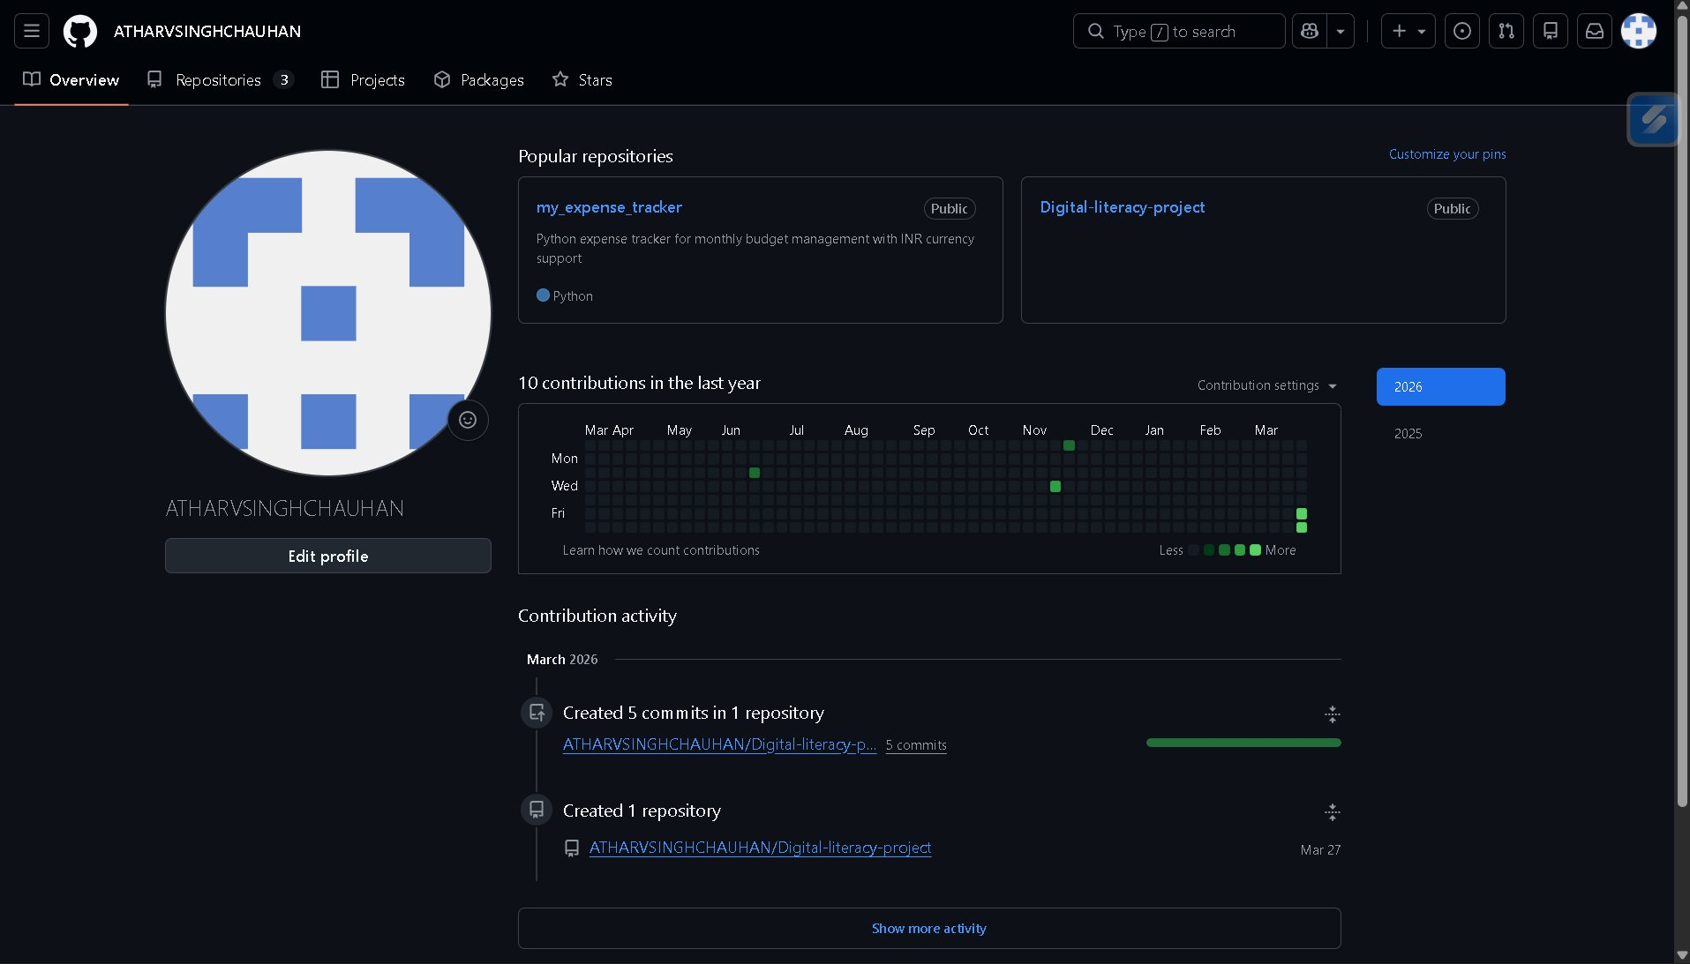

How I Plan to Use Kaggle
- Complete free ML courses: Python, Pandas, Machine Learning, Deep Learning
- Explore public datasets relevant to AI research and coursework
- Participate in Getting Started competitions (Titanic, MNIST etc.)
- Build and publish Kaggle Notebooks as part of my AI portfolio
- Target Kaggle Expert tier with competition medals by third year

Reflection – Platforms, Purpose & Future Plans

Setting up these three platforms marks the beginning of my professional digital identity as an Integrated M.Tech AI student. Each platform serves a distinct and important purpose. GitHub is where my technical work lives — every AI model, Python script, and data science project I build will be stored here. LinkedIn is where my professional story is told — connecting me with the global AI industry. And Kaggle is where my data science skills are built and proven through real competitions and datasets.

As a student of Integrated M.Tech in Artificial Intelligence, I have a unique advantage — my degree is specifically aligned with the skills these platforms reward. Unlike general engineering students, AI/ML students are expected to have active Kaggle profiles, GitHub repositories with model code, and LinkedIn connections in the data science space.

Over the next four to five years, I plan to actively grow all three profiles. By placement season, I aim to have a GitHub with 30+ repositories including AI projects, a LinkedIn profile with 500+ connections and internship experience, and a Kaggle profile with at least one competition medal. These profiles are not just assignment requirements — they are my digital resume for the AI industry.

Portfolio Summary

Platform | Profile | Status | Primary Use
GitHub | ATHARVSINGHCHAUHAN | Active ✅ | AI Code Portfolio
LinkedIn | atharv-chauhan-01574737b | Active ✅ | AI/ML Networking
Kaggle | AtharvSingh1107 | Active ✅ | ML Competitions

Academic Integrity Statement

All profiles documented in this report are my own individual accounts, created using my college email address. All screenshots are genuine captures of my own profiles taken in March 2026. This document is an individual submission prepared for the CSE0001 Digital Literacy course at VIT Bhopal University.

